Using the Lightning Web Components framework, build a table which can display a list of Lead and Opportunity records. Your solution should use the Lightning Datatable component documented here: <https://developer.salesforce.com/docs/component-library/bundle/lightning-datatable>.

Your component should be available to the Lightning App Builder on App Pages and Home Pages and use the provided skeleton project. All server side actions should be implemented using Apex called via the imperative method. All Apex should have at least 85% unit test coverage. Any custom fields, settings or changes required should be included in your project structure in the appropriate SFDX metadata format (i.e. Your deliverable should be self contained and deployable to any org with SFDX with minimal manual config required).

If you have any questions regarding the below requirements, please contact us for clarification.

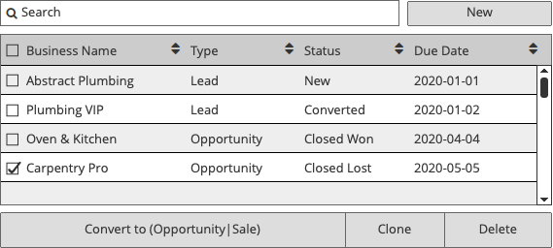

**Requirements**

1. Your component should include all record details as shown in the above wireframe.
2. Your component should be responsive and work on both desktop and mobile environments, adapting to utilize the width and height of any parent container.
3. The component should filter the displayed records by
   1. The currently logged in user (only Accounts owned by the current user should be displayed)
   2. The provided search query, using Business Name as the searchable field
4. The Business Name field should display the related Account Name for each record
5. The Type field should display either Lead or Opportunity, depending on record type
6. The Status field should display the relevant record Status
7. The Due Date field should display a custom Due Date field for Leads, and the Closed Date field for Opportunity
8. Your component should support a large number of records (100+). You do not need to paginate records for this sample, but your table should scroll as needed.
9. The ‘Convert to’ button should display either ‘Convert to Sale’ or ‘Convert to Opportunity’, depending on the records selected.
10. Clicking on New should display the following popup.  
      
     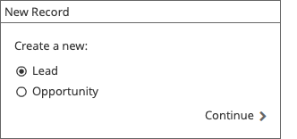  
    1. Clicking Continue should use the native Salesforce Lead or Opportunity new record feature. See: <https://developer.salesforce.com/docs/component-library/documentation/lwc/lwc.use_navigate>
11. Converting one or more eligible Leads to Opportunities should mark the Lead as ‘Converted’ and create Opportunity records using any appropriate fields from the Lead record.
12. Only one record may be selected when converting Opportunities to a Sale. The Convert button should be disabled if multiple opportunities are selected.
13. All buttons should be disabled if no records are selected or eligible for each button action respectively
14. The Clone button should copy the selected records to new records of the same type, but the ‘Due Date’ field (referenced above) should be increased by 1 year.
15. The Delete button should delete all selected records.